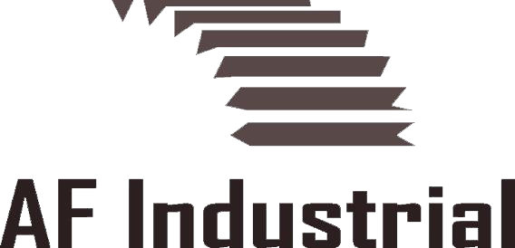

Entrepreneur, Alex Frieling, founder of AF Industrial, retains some of the leading worldwide industrial corporations, making his firm one of the most sought-after service rep organizations in the Midwest for Distributors, OEM’s and End Users. Covering the region - Colorado, Wyoming, Utah, New Mexico, Montana, and Idaho, - AF Industrial provides these industries with experienced and professional sales and manufacturing representatives. Headquartered in Denver, Colorado, AF Industrial was founded in 2012 and built on Frieling’s twelve years of experience with his principals in the profession and well-established industrial associations.

Frieling and his partners currently work together to show end-users and OEM’s the most innovative and value based products in the market. This helps our customers not only save money, but downtime in manufacturing. We only bring products to our customers that we believe will show value. We understand time is money do not waste our customers time. Please see our “principals” tab for current product lines.
These industrial companies comprise hundreds of years of innovations, and almost all are listed with the New York Stock Exchange. According to Frieling, “They chose us based upon our professional and aggressive salesmanship, our product knowledge, and our customer service. We work as a team and have a stake in their success.”

